Link: https://onlinelibrary.wiley.com/doi/10.1002/jpn3.70051


ORIGINAL ARTICLE

Endoscopic findings in the evaluation of gastrointestinal symptoms in pediatric patients post hematopoietic stem cell transplantation
Mordechai Slae, Mor Segal Ben-Or, Ronit Schwell, Diana Pinhasov, Diana Averbuch, Zev Davidovics, Anna Elia, Ehud Even Or, Polina Stepensky, Irina Zaidman
First published: 02 May 2025

https://doi.org/10.1002/jpn3.70051
Mordechai Slae and Mor Segal Ben-Or contributed equally to this study.
Read the full text

Abstract

Objectives
Endoscopy plays a pivotal role in diagnosing gastrointestinal (GI) symptoms of pediatric patients post hematopoietic stem cell transplantation (HSCT). There is very little data on whether endoscopic findings can predict pathological diagnosis and treatment outcomes in the pediatric population. The primary objective was to determine the association between macroscopic and microscopic findings of endoscopies in pediatric patients post-HSCT. A secondary objective was to evaluate whether macroscopic findings can predict treatment outcomes or differentiate between causes of GI symptoms.

Methods
This single-center prospective study analyzed the results of endoscopic evaluation in patients aged 18 years or younger, who developed GI symptoms during and after HSCT and required an endoscopy for diagnosis. Macroscopic and microscopic findings of upper and lower endoscopies were reviewed and compared, thus evaluating the correlation between the two. Predetermined sites throughout the GI tract were examined for their macroscopic and microscopic findings, to examine whether their results suggest graft-versus-host disease (GVHD), infection, or both. Patients' change in treatment and clinical response were also assessed.

Results
In 22 patients, 249 tissue samples were macroscopically and microscopically evaluated. When abnormal macroscopic findings were present, microscopic findings were present in 86.2% of the cases. In 72.1% of the endoscopic sites with normal macroscopic results, abnormal microscopic findings were present (p value = 0.004, Fisher–Freeman–Halton exact test).

Conclusion
This study provides further evidence supporting the correlation between macroscopic and microscopic evaluation in the diagnosis of GVHD post-HSCT, however, normal macroscopic findings do not rule out the presence of GVHD.

Graphical Abstract
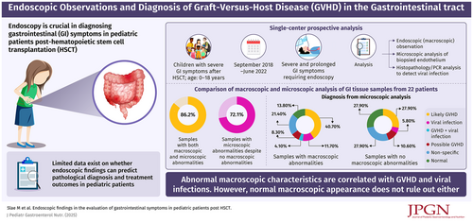

CONFLICT OF INTEREST STATEMENT
The authors declare no conflicts of interest.

