Link: https://onlinelibrary.wiley.com/doi/10.1002/jpn3.70100


ORIGINAL ARTICLE

Dietary intake and risk of nutrient inadequacy among children with pediatric feeding disorders
Jessica Brown, Shonda Brown, Kelsey Childs, Ricardo Aguilar
First published: 10 June 2025

https://doi.org/10.1002/jpn3.70100
Read the full text

Abstract

Objective
Children with pediatric feeding disorders (PFDs) are at risk of malnutrition and micronutrient deficiencies given the inability to consume adequate amounts of foods and beverages, limited dietary diversity, and exclusion of entire food groups. This study evaluated the risk of nutritional inadequacy in children with PFD who did not receive tube feeding support.

Methods
A retrospective chart review of children with PFD referred to a multidisciplinary feeding program for initial consultation between January 2012 and December 2017 was performed. Nutrient intake data were analyzed and compared with the Dietary Reference Intakes and Dietary Guidelines for Americans to assess nutrient inadequacy risk. Two-sample t tests and chi-squared tests were conducted to examine bivariate associations. The effects of demographic, anthropometric, and dietary characteristics on the frequency of at-risk nutrient inadequacies were modeled using quasi-Poisson regression.

Results
Eighty-nine children (ages 1–15 years) were included in this study. Children consumed less than the recommended daily servings of fruit, dairy, grains, protein foods, and vegetables (55.8%, 53.7%, 52.7%, 32.3%, and 23.3%, respectively). Less than 20% of children consumed all five food groups. Children consumed an average of 8.4 unique foods per day. Forty-nine percent were at risk of nutrient inadequacies for ≥5 nutrients analyzed. Mean body mass index (BMI) z-score was −0.59.

Conclusions
BMI is a gross indicator of nutritional status but is not an accurate measure of nutrient sufficiency. Children with PFD fall short of established dietary recommendations and are at risk of multiple nutrient inadequacies, which oral supplements reduce but do not eliminate.

Graphical Abstract
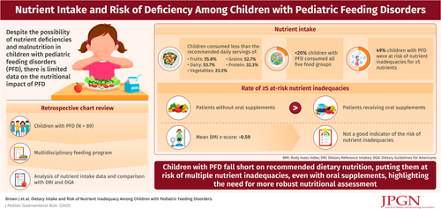

CONFLICT OF INTEREST STATEMENT
The authors declare no conflicts of interest.

