Link: https://onlinelibrary.wiley.com/doi/10.1002/jpn3.70081


ORIGINAL ARTICLE

An ultrasound approach to visualize the “duct at the hilum” in infants undergoing evaluation for biliary atresia
Ashley M. Upton, Jose A. Hernandez, Benjamin L. Shneider, Tebyan A. Rabbani, Sridevi Devaraj, Kalyani R. Patel, Sanjeev A. Vasudevan, Adam M. Vogel, Sanjiv Harpavat
First published: 02 June 2025

https://doi.org/10.1002/jpn3.70081
Read the full text

Abstract

Objectives
Ultrasound exams are commonly used to evaluate infants for biliary atresia. However, ultrasound findings may be inconclusive, and more invasive diagnostic testing is often required. We hypothesized that another ultrasound finding—absence of the extrahepatic bile duct at the liver hilum (the “duct at the hilum”)—could be useful.

Methods
Ultrasound exams were reviewed from infants undergoing evaluation for biliary atresia at Texas Children's Hospital during two periods. First, exams performed before 2021 were reviewed to develop a systematic approach to visualize the duct at the hilum. Second, exams performed during a subsequent 26-month period were reviewed to assess the approach's diagnostic performance.

Results
A four-step approach to visualize the duct at the hilum was developed, based on location, position, length, and absence of blood flow specifications. The approach was then performed on 64 infants with a median age of 25 days (range: 0–170 days) and a median weight of 3.2 kg (range: 1.0–6.3 kg). The approach identified all 12 patients with biliary atresia and excluded 49 out of 52 infants without biliary atresia, for a sensitivity of 1.00 (95% confidence interval [CI]: 0.70–1.00) and specificity of 0.94 (95% CI: 0.83–0.99). The approach could be performed in feeding infants and often in <5 min.

Conclusions
We present a systematic approach to visualize the duct at the hilum, which does not require fasting and may efficiently exclude infants who do not have biliary atresia. Future, multisite studies are needed to determine how the approach performs in larger populations and in different healthcare settings.

Graphical Abstract
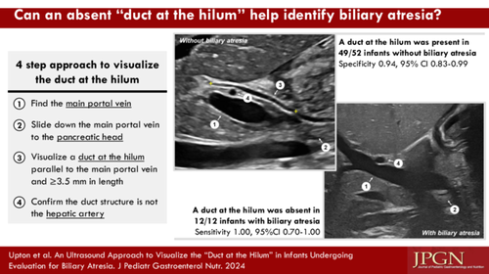

CONFLICT OF INTEREST STATEMENT
Sanjiv Harpavat serves on the DSMB for a therapeutic trial for biliary atresia (DSMB coordinated by Syneos Health). The remaining authors declare no conflicts of interest.

